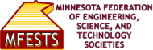
CONTACT INFORMATION:
MFESTS
Theo Black, Public Relations
952-261-5559
tblack@memberleader.asq.org

FOR IMMEDIATE RELEASE

Gary A. Davis Receives the Minnesota Federation of Engineering, Science, and Technology Societies Charles W. Britzius
Distinguished Engineer Award

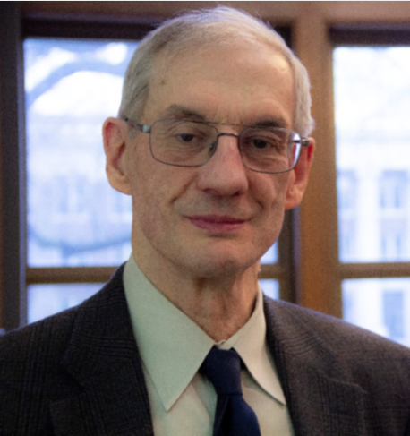
Saint Paul, Minn., 12/1/2022 – Minnesota Federation of Engineering, Science, and Technology Societies (MFESTS) and the American Society of Civil Engineers (ASCE) Minnesota Section have named Gary A. Davis as the 2022 recipient of the Charles W. Britzius Distinguished Engineer Award.

The Minnesota Federation of Engineering, Science and Technology Societies (MFESTS) presents this award annually to a nominated individual submitted by MFESTS member societies which includes the American Society of Civil Engineers (ASCE), Minnesota Section. The award will be presented at the 2022-2023 MFESTS Awards Ceremony to be held in May.

The Charles W. Britzius Distinguished Engineer Award recognizes outstanding lifetime achievements in the practice of engineering, contributions to the engineering profession, and actions enhancing the image of engineering in our society. Charles W. Britzius was the epitome of the distinguished engineer, having excelled in all three areas recognized by the award: he was the founder of Twin City Testing, Inc.; was a long-time contributor to the Minnesota Society of Professional Engineers and the American Society of Civil Engineers, Minnesota Section; served as mayor of Deephaven; and was a tireless supporter of numerous professional and civic causes.

St. Louis Park, MN resident Gary A. Davis A Master of Science in Civil Engineering and a Doctor of Philosophy in Civil Engineering, both from the University of Washington. Davis is a professor in the Department of Civil, Environmental, and Geo- Engineering at the University of Minnesota where he teaches undergraduate and graduate courses that include engineering ethics, introductory and advanced statistics and data analysis, transportation engineering, traffic engineering and highway design, travel demand modeling, and applications of stochastic processes. His duties include conducting basic and applied research relevant to transportation engineering.

"The MFESTS award nomination process realizes many career benefits such as reflection for our members to take stock of unique contributions and motivates our members to seek feedback to achieve further stretch goals" said Cathy Krier, MFESTS 2020-2022 President. "Based on the nomination channels, the MFESTS recognition process ultimately boosts the immediate and long-term visibility of the member’s science/engineering contributions across the widest range of engineering disciplines collectively represented by the member societies, reaching the broader Science, Technology, Engineering, and Mathematics community in Minnesota."

Professor Gary Davis was nominated in recognition of his research accomplishments, his contributions to engineering education, and his professional service. He is an internationally recognized expert in highway traffic safety and the application of advanced statistical methods in transportation engineering. He is also distinguished by a commitment to sharing his understanding with students at both the undergraduate and graduate levels. A hallmark of Davis’s research is an interest in reliably learning about road safety processes from limited or uncertain information, and he combines a wide knowledge of probability and statistics with the creative application of this knowledge to practical problems. His research ranges broadly, from applications of standard analytic tools to immediate practical problems to the deployment of deeper philosophical ideas underlying cause and effect.

MFESTS is an umbrella organization comprised of engineering-related member societies within the State of Minnesota. There currently are nineteen societies/chapters, representing approximately 6,000 individuals, that are members of MFESTS.

MFESTS three primary mission foci are:
1) To provide service to the Societies that are members of the Federation.
2) To provide a service to the community at large and especially to young people in hopes of helping them learn more about potential careers in the fields of engineering, science, and technology.
3) To provide professional development services to professionals in engineering-related careers.

The American Society of Civil Engineers (ASCE) is one of the member societies of MFESTS. It is a non-profit professional organization founded in 1852 with over 150,000 members worldwide. Locally, the Minnesota Section was established in 1914, and represents more than 1400 members that work in all levels of government, academia and the private sector to design, construct and maintain our State’s infrastructure. One of ASCE’s key responsibilities is to advocate for infrastructure stewardship in an effort to protect the public’s health, safety, and improve our quality of life. The Minnesota Section represents all of Minnesota except for the Counties in the northeast portion of the state, which are part of the Duluth Section.

###

