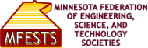
CONTACT INFORMATION:
MFESTS
Theo Black, Public Relations
952-261-5559
tblack@memberleader.asq.org

FOR IMMEDIATE RELEASE

Timothy A. Peterson Receives the Minnesota Federation of Engineering, Science, and Technology Societies Richard Alberg Distinguished Science and Technology Professional Award

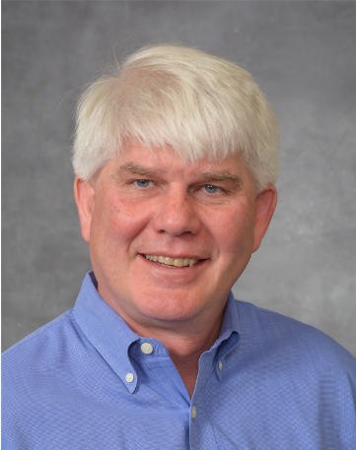
Saint Paul, Minn., 12/1/2022 – Minnesota Federation of Engineering, Science, and Technology Societies (MFESTS) and the American Society for Quality (ASQ) - Minnesota Section have named Timothy Peterson as the 2022 recipient of the Richard Alberg Distinguished Science and Technology Professional Award.

The Minnesota Federation of Engineering, Science and Technology Societies (MFESTS) presents this award annually to a nominated individual submitted by MFESTS member societies which includes the American Society for Quality (ASQ), Minnesota Section. The award will be presented at the 2022-2023 MFESTS Awards Ceremony to be held in May.

The Richard Alberg Distinguished Science and Technology Professional award recognizes outstanding lifetime achievements in the recipient’s practice of science and technology, contributions to their profession, and actions enhancing the image of science and technology in the society. Dick Alberg was a board member of MFESTS and of the Minnesota Section of ASQ at the time of his passing in 2005. He thoroughly enjoyed working in the field of quality engineering and traveled around the world providing his expertise to various manufacturing facilities.

Victoria, MN resident Tim Peterson holds a Bachelor of Arts degree in Biology from St. Olaf College in Northfield Minnesota, a Master of Science degree in Reproductive Physiology from the University of Wyoming in Laramie Wyoming, and a Master of Business Administration degree from Augsburg College in Minneapolis. Tim is a Senior Manufacturing Engineer at Abbott Medical, where he develops and supports manufacturing processes that supply internal customers with extruded parts for medical device assembly. He provides Quality Support of Abbott Manufacturing Validation Efforts. Tim is an ASQ Certified Quality Engineer, and is a leader and member of the Biomedical Consortium task group of the Minnesota section of the American Society for Quality (MNASQ).

"The MFESTS award nomination process realizes many career benefits such as reflection for our members to take stock of unique contributions and motivates our members to seek feedback to achieve further stretch goals" said Cathy Krier, MFESTS 2020-2022 President. "Based on the nomination channels, the MFESTS recognition process ultimately boosts the immediate and long-term visibility of the member’s science/engineering contributions across the widest range of engineering disciplines collectively represented by the member societies, reaching the broader Science, Technology, Engineering, and Mathematics community in Minnesota."

Tim Peterson was nominated for outstanding dedication and service to the Minnesota Section of the American Society for Quality, and for exceptional contributions to the Medical Device Community through publications, career achievement and facilitation of seminars, webinars, and workshops within the Biomedical community in Minnesota. His contributions to other non-engineering activities have enhanced the image of engineers in our society.

The Minnesota Federation of Engineering, Science, and Technology Societies (MFESTS) is an umbrella organization comprised of engineering-related member societies within the State of Minnesota. There currently are nineteen societies/chapters, representing approximately 6,000 individuals, that are members of MFESTS.

MFESTS three primary mission foci are:
1) To provide service to the Societies that are members of the Federation.
2) To provide a service to the community at large and especially to young people in hopes of helping them learn more about potential careers in the fields of engineering, science, and technology.
3) To provide professional development services to professionals in engineering-related careers.

The American Society for Quality (ASQ) - Minnesota Section is one of the member societies of MFESTS. Founded in 1948, ASQ Minnesota Section has grown to be one of the largest sections within ASQ. With over 1400 members, approximately 80% of its members live or work within the Greater Twin Cities area. ASQ Minnesota Section's mission is to foster personal and professional relationships, connections, and a sense of belonging, and to equip its community with the skills, competencies and knowledge that create Excellence Through Quality.

###

